**Part B - Plan**

**Aim Of The Project:** Micro-Project On Medical Store Management System.

**Brief Description :**

* The micro-project consist of 2 main module that are as follows:-
  + Admin
  + Staff
* The admin and staff module further consist of more options such as add drug ,manage stock, manage patient ,etc
* The project also consist of a database which stores the entered data for further use
* The project is fully secure and needs password to access the admin &staff module
* The admin module has 2 additional features as compared to staff they are as follows :-
  + - Manage stock
    - Manage Patient
* We have used different visual studio tools in the project such as buttons,textboxes,panels,etc

**Aim Of Micro Project :**

* This Micro Project Aims To:

1. Develop Program Using Visual Studio 2012 Application.
2. Detailed Study Of Each And Every Concept Of Vb.Net.
3. Increase The Speed Of Some Vital Process Of Medical Store
4. Reduce Human Efforts.
5. To Maintain Accurate Patient Records, Stock Records, Etc Using Access Database.

**Course Outcome Integrated :**

* Use Visual Studio Ide To Design Application
* Develop Gui Application Using Form Controls And Its Event
* Use Data Access Control To Store Data In Database Retrieve It

**Actual Procedure Followed :**

1. **Group Formation:-** Gad Is A Subjects Which Helps Us To Learn About Different Concepts Of Vb.Net Using Visual Studios The Basic Aim Of Micro- Project Is To Accelerate The Attainment Of The Variouse Outcome In The Course.In The First 2 Weeks Of December The Subject Was Introduced To Us .The Syllabus As Well As Details Of Micro-Project Was Discussed.The Group Of 3 Memebers Were Formed And The Group Leaders Were Selected.The Schedule Of Plan “A”,”B”& “Presentation” Were Finalized.The Variouse Micro-Project Topics Related To Subject Was Discussed Our Guide Gave Us The Opportunity To Select The Topic Of Our Choice.
2. **Finalization Of Micro-Project:-** After Attending The Lectures For 2 Weeks.We Selected The Topic For Micro-Project.We Discussed The Topic With Our Guide Regarding The Concept Which We Are Going To Apply In The Project.We Individually Tried To Explain The Basic Platform Of Project.
3. **Planning:-** After Finalization Of The Project We Started Working On The Project.We Started The Planning Phase.We Discussed Among Ourselves Regarding The Resources Such As Hardware & Software Requirements .In This Week We Completed ‘Part A Plan’ Of The Micro-Project Which Is Nothing But A Initial Description About The Project.We Submitted It To The Guide.
4. **Module Distribution &Analysis Part:-** Once The Planning Was Over Regarding Resources,Etc.We Finalized The Module (Part) Of Project Which We Will Be Developing According To Members We Distributed The Module Among Us We Started The Analysis Of Project.
5. **Design Part :-**  We Designed All The Module That Were Needed To Be Included In The Project.While Designing The Module We Used Different Visual Studio Tools Such As Buttons,Textboxboxes,Panels ,Etc.
6. **Implementation :-** In The Week We Actually Started The Technical Phase .In This Phase We Created The Database Needed For The Project And We Also Completed The Coding Part Of The Module Assighned To Us.
7. **Presentation :-** In This Week We Have To Present The Micro-Project In Front Of The Guide.Each Member Of Group Presented Their Own Parts With Confidence In Front Of Guide.She Asked Us Variouse Queries Regarding The Topics.We Presented The Details Of Each Concept Of Assembly Language Programming That We Used In The Project.She Asked Us To Do Variouse Changes Regarding Some Topics.
8. **Submission:-** This Week Was Submission Week.We Submitted Our Project Along With ‘Part A & B Plan’ To The Guide.We Also Submitted The Hard Copies And Soft Copies Of Project To The Guide

**Actual Resources Used :**

|  |  |  |  |  |
| --- | --- | --- | --- | --- |
| **Sr.No** | **Name Of The Resources Required** | **Specifications** | **Quantity** | **Remarks** |
| **1.** | Computer | **Processor**-Amd  **Hard Disk-**2 Tb  **Ram**-16gb  **Operating System**-Windows 10 Pro | 1  1  1  1 | Hardware And Software Used |
| **2.** | Visual Studio | Visual Studio 2012 | 1 | Ide And Compiler For Vb.Net Programming |
| **4** | Microsoft Access | Microsoft 2010 | 1 | Software Used For Database Creation |

**Output Of The Micro- Project :**

The Output Of The Project Is According To Following Index :

|  |  |
| --- | --- |
| **Sr No** | **Content** |
| **1** | Code |
| **2** | Code Output |
| **3** | References |

**Code**

**Add Patient.Vb-**

Imports System.Data

Imports System.Data.Oledb

Public Class Patient

Private Sub Button1_Click(Sender As Object, E As Eventargs) Handles Button1.Click

If Textbox1.Text = "" Then Textbox1.Focus() : Exit Sub

If Textbox2.Text = "" Then Textbox2.Focus() : Exit Sub

If Textbox3.Text = "" Then Textbox3.Focus() : Exit Sub

If Textbox4.Text = "" Then Textbox4.Focus() : Exit Sub

If Textbox5.Text = "" Then Textbox5.Focus() : Exit Sub

If Textbox6.Text = "" Then Textbox6.Focus() : Exit Sub

If Textbox7.Text = "" Then Textbox7.Focus() : Exit Sub

If Textbox8.Text = "" Then Textbox8.Focus() : Exit Sub

If Textbox9.Text = "" Then Textbox9.Focus() : Exit Sub

If Textbox10.Text = "" Then Textbox10.Focus() : Exit Sub

Con.Close()

Con.Open()

Cmd = New Oledbcommand(" Insert Into Patient Values('" + Textbox1.Text + "','" + Textbox2.Text + "','" + Textbox3.Text + "','" + Textbox4.Text + "','" + Textbox5.Text + "','" + Textbox6.Text + "','" + Textbox7.Text + "','" + Textbox8.Text + "','" + Textbox9.Text + "','" + Textbox10.Text + "')", Con)

Dim I As Integer = Cmd.Executenonquery()

If (I > 0) Then

Msgbox("Record Saved Sucessfullly", Msgboxstyle.Information, Msgboxstyle.Okonly)

Clr()

Else

Msgbox("Record Not Saved !!!", Msgboxstyle.Critical, Msgboxstyle.Okonly)

End If

Con.Close()

End Sub

Public Sub Clr()

Textbox1.Clear()

Textbox2.Clear()

Textbox3.Clear()

Textbox4.Clear()

Textbox5.Clear()

Textbox6.Clear()

Textbox7.Clear()

Textbox8.Clear()

Textbox9.Clear()

Textbox10.Clear()

End Sub

Private Sub Button2_Click(Sender As Object, E As Eventargs) Handles Button2.Click

Textbox1.Clear()

Textbox2.Clear()

Textbox3.Clear()

Textbox4.Clear()

Textbox5.Clear()

Textbox6.Clear()

Textbox7.Clear()

Textbox8.Clear()

Textbox9.Clear()

Textbox10.Clear()

End Sub

Private Sub Button3_Click(Sender As Object, E As Eventargs) Handles Button3.Click

Main.Show()

Me.Hide()

End Sub

Private Sub Button4_Click(Sender As Object, E As Eventargs) Handles Button4.Click

My.Forms.Loginform1.Show()

Me.Hide()

End Sub

End Class

**Drug.Vb**

Imports System.Data

Imports System.Data.Oledb

Public Class Drug

Private Sub Button3_Click(Sender As Object, E As Eventargs) Handles Button3.Click

Main.Show()

Me.Hide()

End Sub

Private Sub Button4_Click(Sender As Object, E As Eventargs) Handles Button4.Click

Loginform1.Show()

Me.Hide()

End Sub

Private Sub Button1_Click(Sender As Object, E As Eventargs) Handles Button1.Click

If Textbox1.Text = "" Then Textbox1.Focus() : Exit Sub

If Textbox2.Text = "" Then Textbox2.Focus() : Exit Sub

If Textbox3.Text = "" Then Textbox3.Focus() : Exit Sub

If Textbox4.Text = "" Then Textbox4.Focus() : Exit Sub

If Textbox5.Text = "" Then Textbox5.Focus() : Exit Sub

If Textbox6.Text = "" Then Textbox6.Focus() : Exit Sub

Con.Close()

Con.Open()

Cmd = New Oledbcommand(" Insert Into Drug Values('" + Textbox1.Text + "','" + Textbox2.Text + "','" + Textbox3.Text + "','" + Textbox4.Text + "','" + Textbox5.Text + "','" + Textbox6.Text + "')", Con)

Dim Ab As Integer = Cmd.Executenonquery()

If (Ab > 0) Then

Msgbox("Record Saved Sucessfullly", Msgboxstyle.Information, Msgboxstyle.Okonly)

Clr()

Else

Msgbox("Record Not Saved !!!", Msgboxstyle.Critical, Msgboxstyle.Okonly)

End If

Con.Close()

End Sub

Public Sub Clr()

Textbox1.Clear()

Textbox2.Clear()

Textbox3.Clear()

Textbox4.Clear()

Textbox5.Clear()

Textbox6.Clear()

End Sub

Private Sub Button2_Click(Sender As Object, E As Eventargs) Handles Button2.Click

Clr()

End Sub

End Class

**Edit Patient.Vb**

Imports System.Data.Oledb

Public Class Editpatient

Private Sub Button2_Click(Sender As Object, E As Eventargs) Handles Button2.Click

Dim Msg As Integer = Msgbox("Do You Really Want To Delete The Respective Patient Record ", Msgboxstyle.Yesnocancel, "Delete Patient Record")

If Msg = Dialogresult.Yes Then

Con.Close()

Con.Open()

Str = "Delete From Patient Where Patientid=@Id"

Cmd = New Oledbcommand(Str, Con)

Cmd.Parameters.Addwithvalue("@Id", Combobox1.Text)

Cmd.Executenonquery()

Msgbox("Patient Record Deleted", Msgboxstyle.Information, Msgboxstyle.Okonly)

Clr()

Con.Close()

End If

End Sub

Public Sub Clr()

Textbox2.Clear()

Textbox3.Clear()

Textbox4.Clear()

Textbox5.Clear()

Textbox6.Clear()

Textbox7.Clear()

Textbox8.Clear()

Textbox9.Clear()

Textbox10.Clear()

End Sub

Private Sub Button1_Click(Sender As Object, E As Eventargs)

Clr()

End Sub

Private Sub Button3_Click(Sender As Object, E As Eventargs) Handles Button3.Click

Main.Show()

Me.Hide()

End Sub

Private Sub Button4_Click(Sender As Object, E As Eventargs) Handles Button4.Click

Loginform1.Show()

Me.Hide()

End Sub

Private Sub Button1_Click_1(Sender As Object, E As Eventargs) Handles Button1.Click

Con.Open()

Str = "Update Patient Set Age='" & Textbox10.Text &

"',Patientname='" & Textbox2.Text & "',Gender='" & Textbox3.Text &

"',Contactnumber='" & Textbox6.Text & "',Ward='" & Textbox5.Text &

"',Alternatecontactnumber='" & Textbox4.Text & "',Treatingdoctor='" & Textbox7.Text & "',Accidentdiseasetype='" & Textbox8.Text &

"',Bedroomno='" & Textbox9.Text & "'

Where Patientid='" & Combobox1.Text & "'"

Cmd = New Oledbcommand(Str, Con)

Cmd.Executenonquery()

Msgbox("Records Updated")

Con.Close()

End Sub

Private Sub Panel1_Paint(Sender As Object, E As Painteventargs) Handles Panel1.Paint

Patientid()

End Sub

Public Sub Patientid()

Con.Close()

Con.Open()

Str = "Select *From Patient"

Cmd = New Oledbcommand(Str, Con)

Da.Selectcommand = Cmd

Da.Fill(Ds, "Patient")

Dim A As Integer = Ds.Tables("Patient").Rows.Count - 1

For I As Integer = 0 To A

Combobox1.Items.Add(Ds.Tables("Patient").Rows(I)(0).Tostring())

Next

End Sub

Private Sub Button5_Click(Sender As Object, E As Eventargs) Handles Button5.Click

Con.Close()

Con.Open()

Cmd = New Oledbcommand(Str, Con)

If Isnumeric(Combobox1.Text) Then

Cmd.Commandtext = "Select * From Patient Where Patientid=@Pid"

Cmd.Prepare()

Cmd.Parameters.Addwithvalue("@Pid", Combobox1.Text)

Dim Dr As Oledbdatareader = Cmd.Executereader()

Dr.Read()

Textbox2.Text = Dr.Getvalue(2)

Textbox3.Text = Dr.Getvalue(3)

Textbox4.Text = Dr.Getvalue(6)

Textbox5.Text = Dr.Getvalue(5)

Textbox6.Text = Dr.Getvalue(4)

Textbox7.Text = Dr.Getvalue(7)

Textbox8.Text = Dr.Getvalue(8)

Textbox9.Text = Dr.Getvalue(9)

Textbox10.Text = Dr.Getvalue(1)

End If

End Sub

End Class

**Login.Vb**

Imports System.Data

Imports System.Data.Oledb

Public Class Loginform1

Private Sub Ok_Click(Byval Sender As System.Object, Byval E As System.Eventargs) Handles Login.Click

If Usernametextbox.Text = "" Then Usernametextbox.Focus() : Exit Sub

If Passwordtextbox.Text = "" Then Passwordtextbox.Focus() : Exit Sub

Cmd = New Oledbcommand("Select * From Login Where Username='" + Usernametextbox.Text + "'And Password='" + Passwordtextbox.Text + "'", Con)

Con.Close()

Con.Open()

Dim Dr As Oledbdatareader = Cmd.Executereader()

If Dr.Hasrows Then

Con.Close()

Me.Hide()

Main.Show()

Else

Msgbox("User-Id And Password Not Matched", Msgboxstyle.Critical, Msgboxstyle.Okonly)

End If

Usernametextbox.Clear()

Passwordtextbox.Clear()

End Sub

Private Sub Cancel_Click(Byval Sender As System.Object, Byval E As System.Eventargs)

Me.Close()

End Sub

End Class

**Main.Vb**

Imports System.Data

Imports System.Data.Oledb

Public Class Main

Private Sub Button2_Click(Sender As Object, E As Eventargs) Handles Button2.Click

Patient.Show()

Me.Hide()

End Sub

Private Sub Button5_Click(Sender As Object, E As Eventargs) Handles Button5.Click

Editpatient.Show()

Me.Hide()

End Sub

Private Sub Button1_Click(Sender As Object, E As Eventargs) Handles Button1.Click

Drug.Show()

Me.Hide()

End Sub

Private Sub Button6_Click(Sender As Object, E As Eventargs) Handles Button6.Click

Main2.Show()

Me.Hide()

End Sub

Private Sub Button3_Click(Sender As Object, E As Eventargs) Handles Button3.Click

Stock.Show()

End Sub

Private Sub Button4_Click(Sender As Object, E As Eventargs) Handles Button4.Click

Splashscreen1.Show()

Me.Hide()

End Sub

Private Sub Main_Load(Sender As Object, E As Eventargs) Handles Mybase.Load

If Loginform1.Usernametextbox.Text = "Staff" Then

Button5.Enabled = False

Button3.Enabled = False

Label4.Backcolor = Color.Black

Label3.Backcolor = Color.Black

End If

End Sub

End Class

**Main2.Vb**

Public Class Main2

Dim Billno As Integer = 0

Private Sub Button1_Click(Sender As Object, E As Eventargs) Handles Button1.Click

Main.Show()

Me.Hide()

End Sub

Private Sub Button6_Click(Sender As Object, E As Eventargs) Handles Button6.Click

Loginform1.Show()

Me.Hide()

End Sub

Private Sub Tablelayoutpanel1_Paint(Sender As Object, E As Painteventargs)

End Sub

Dim Num As Integer = 1

Private Sub Button3_Click(Sender As Object, E As Eventargs) Handles Button3.Click

Dim Name As String = Textbox8.Text

Dim Quantity As Decimal = Textbox9.Text

Dim Price As Decimal = Textbox10.Text

Dim Subtotal As Decimal = Quantity * Price

Datagridview1.Rows.Add(Num, Name, Quantity, Price, Subtotal)

Num += 1

Calculate()

Clr()

End Sub

Private Sub Clr()

Textbox8.Clear()

Textbox9.Clear()

Textbox10.Clear()

End Sub

Private Sub Calculate()

Dim Sum As Decimal = 0

For I = 0 To Datagridview1.Rows.Count - 1

Sum += Datagridview1.Rows(I).Cells(4).Value

Next

Textbox11.Text = Sum

End Sub

Private Sub Button2_Click(Sender As Object, E As Eventargs) Handles Button2.Click

If Datagridview1.Selectedrows.Count = 0 Then

Exit Sub

End If Datagridview1.Rows.Remove(Datagridview1.Selectedrows(0))

Calculate()

End Sub

Private Sub Button4_Click(Sender As Object, E As Eventargs) Handles Button4.Click

Textbox2.Clear()

Textbox3.Clear()

Textbox4.Clear()

Textbox5.Clear()

Textbox6.Clear()

Textbox7.Clear()

Textbox8.Clear()

Textbox9.Clear()

Textbox10.Clear()

Textbox11.Clear()

Datagridview1.Rows.Clear()

Textbox11.Text = 0

End Sub

Private Sub Button5_Click(Sender As Object, E As Eventargs) Handles Button5.Click

If Datagridview1.Rows.Count = 0 Then

Exit Sub

End If

Billno += 1

Printpreviewdialog1.Windowstate = Formwindowstate.Maximized

Printpreviewdialog1.Startposition = Formstartposition.Centerscreen

Printpreviewdialog1.Printpreviewcontrol.Zoom = 1.5

Printpreviewdialog1.Document = Printdocument1

Printpreviewdialog1.Showdialog()

Button4_Click(Nothing, Nothing)

End Sub

Private Sub Printdocument1_Printpage(Sender As Object, E As Printing.Printpageeventargs) Handles Printdocument1.Printpage

Dim Rows As Datagridviewrowcollection = Me.Datagridview1.Rows

Dim Unitwidth As Integer = 57

Dim Unitheight As Integer = 22

Dim Leftmargin As Integer = 0

Dim Topmargin As Integer = 0

Dim Reciptdetailsheight = Rows.Count * Unitheight

Dim Font As New Font("Times", 12)

Dim Fontb As New Font("Times", 12, Fontstyle.Bold)

Dim Fontbold As New Font("Times", 12, Fontstyle.Bold)

Dim Fontboldheader As New Font("Times", 16, Fontstyle.Bold)

Dim Trectwidth As Integer = 790

Dim Str As New Stringformat

Str.Alignment = Stringalignment.Center

Dim Strleft As New Stringformat

Strleft.Alignment = Stringalignment.Near

Dim Strright As New Stringformat

Strright.Alignment = Stringalignment.Far

Dim Ybillstart As Integer = 4 * Unitheight

Dim Yheadstart As Integer = Ybillstart + (3 * Unitheight)

Dim Ydetailstart As Integer = Yheadstart + Unitheight

Dim Rect As New Rectangle(Leftmargin + 0, Topmargin + 0, Trectwidth, Unitheight + 10)

E.Graphics.Drawrectangle(Pens.White, Rect)

Dim Rect1 As New Rectangle(Leftmargin + 0, Topmargin + Unitheight, Trectwidth, Unitheight)

E.Graphics.Drawrectangle(Pens.White, Rect1)

Dim Rect2 As New Rectangle(Leftmargin + 0, Topmargin + Unitheight * 2, Trectwidth, Unitheight * 3

E.Graphics.Drawrectangle(Pens.White, Rect5)

Dim Dtvalue As String = Format(Now.Date, "Dd-Mmm-Yyyy")

E.Graphics.Drawstring(Textbox12.Text, Fontboldheader, Brushes.Black, Rect, Str)

Dim P As New Point(0, 70)

Dim Pt As New Point(1000, 70)

Dim P1 As New Point(0, 130)

Dim P2 As New Point(1000, 130)

E.Graphics.Drawstring("Branch :" & Textbox13.Text, Fontbold, Brushes.Black, Rect1, Str)

E.Graphics.Drawstring(" Code :" & Textbox14.Text, Fontbold, Brushes.Black, Rect2, Str)

E.Graphics.Drawline(Pens.Red, P, Pt)

E.Graphics.Drawstring("Generated By Staff Number :" & Textbox15.Text, Fontbold, Brushes.Black, Rect3, Strright)

E.Graphics.Drawstring("Date : " & Dtvalue, Fontbold, Brushes.Black, Rect4, Strleft)

E.Graphics.Drawstring("Bill No : " & Billno, Fontbold, Brushes.Black, Rect5, Strleft)

E.Graphics.Drawline(Pens.Red, P1, P2)

Dim Rect01 As New Rectangle(Leftmargin + Unitwidth * 1, Topmargin + Yheadstart, Unitwidth * 1, Unitheight)

Dim Rect02 As New Rectangle(Leftmargin + Unitwidth * 1, Topmargin + Yheadstart, Unitwidth * 6, Unitheight)

Dim Rect03 As New Rectangle(Leftmargin + Unitwidth * 7, Topmargin + Yheadstart, Unitwidth * 2, Unitheight)

Dim Rect04 As New Rectangle(Leftmargin + Unitwidth * 9, Topmargin + Yheadstart, Unitwidth * 2, Unitheight)

Dim Rect05 As New Rectangle(Leftmargin + Unitwidth * 11, Topmargin + Yheadstart, Unitwidth * 2, Unitheight)

E.Graphics.Drawstring("Srno", Font, Brushes.Black, Rect01, Str)

E.Graphics.Drawstring("Iteam Name", Font, Brushes.Black, Rect02, Str)

E.Graphics.Drawstring("Quantity", Font, Brushes.Black, Rect03, Str)

E.Graphics.Drawstring("Price", Font, Brushes.Black, Rect04, Str)

E.Graphics.Drawstring("Sub Total", Font, Brushes.Black, Rect05, Str)

Dim A As New Rectangle(Leftmargin + Unitwidth * 1, Topmargin + Ydetailstart, Unitwidth * 1, Unitheight)

Dim C As New Rectangle(Leftmargin + Unitwidth * 1, Topmargin + Ydetailstart, Unitwidth * 6, Unitheight)

Dim D As New Rectangle(Leftmargin + Unitwidth * 7, Topmargin + Ydetailstart, Unitwidth * 2, Unitheight)

Dim H As New Rectangle(Leftmargin + Unitwidth * 9, Topmargin + Ydetailstart, Unitwidth * 2, Unitheight)

Dim F As New Rectangle(Leftmargin + Unitwidth * 11, Topmargin + Ydetailstart, Unitwidth * 2, Unitheight)

Dim I As Integer

For I = 0 To Rows.Count - 1

Dim Yloc = Unitheight * I + Ydetailstart

Dim Rect1g As New Rectangle(Leftmargin + Unitwidth * 1, Topmargin + Yloc, Unitwidth * 1, Unitheight)

Dim Rect2g As New Rectangle(Leftmargin + Unitwidth * -1.7, Topmargin + Yloc, Unitwidth * 6, Unitheight)

Dim Rect3g As New Rectangle(Leftmargin + Unitwidth * 2.9, Topmargin + Yloc, Unitwidth * 2, Unitheight)

Dim Rect4g As New Rectangle(Leftmargin + Unitwidth * 7, Topmargin + Yloc, Unitwidth * 2, Unitheight)

Dim Rect5g As New Rectangle(Leftmargin + Unitwidth * 8.9, Topmargin + Yloc, Unitwidth * 2, Unitheight)

Dim Rect6g As New Rectangle(Leftmargin + Unitwidth * 10.8, Topmargin + Yloc, Unitwidth * 2, Unitheight)

E.Graphics.Drawstring(Rows(I).Cells(0).Value, Font, Brushes.Black, Rect2g, Str)

E.Graphics.Drawstring(Rows(I).Cells(1).Value, Font, Brushes.Black, Rect3g, Str)

E.Graphics.Drawstring(Rows(I).Cells(2).Value, Font, Brushes.Black, Rect4g, Str)

E.Graphics.Drawstring(Rows(I).Cells(3).Value, Font, Brushes.Black, Rect5g, Str)

E.Graphics.Drawstring(Rows(I).Cells(4).Value, Font, Brushes.Black, Rect6g, Str)

Next

Dim Rect4x As New Rectangle(Leftmargin + Unitwidth + 1, Topmargin + Reciptdetailsheight + Ybillstart + 1 + (Unitheight * 4), Trectwidth, Unitheight)

E.Graphics.Drawstring("Total Iteams :" & Rows.Count - 1, Font, Brushes.Black, Rect4x, Strleft)

Dim Rect5a As New Rectangle(Leftmargin + 60, Topmargin + Reciptdetailsheight + Ybillstart + 1 + (Unitheight * 5), Trectwidth - 45, Unitheight)

E.Graphics.Drawrectangle(Pens.Black, Rect5a)

Dim Recipttotal As Decimal = Textbox11.Text

E.Graphics.Drawstring("Total Bill :" & Recipttotal, Fontbold, Brushes.Black, Rect5a, Str)

Dim Rect6a As New Rectangle(Leftmargin + 60, Topmargin + Reciptdetailsheight + Ybillstart + 1 + (Unitheight * 10), Trectwidth - 90, Unitheight)

Dim Rect7a As New Rectangle(Leftmargin + 60, Topmargin + Reciptdetailsheight + Ybillstart + 1 + (Unitheight * 11), Trectwidth - 135, Unitheight)

Dim Rect8a As New Rectangle(Leftmargin + 60, Topmargin + Reciptdetailsheight + Ybillstart + 1 + (Unitheight * 12), Trectwidth - 180, Unitheight)

Dim Rect9a As New Rectangle(Leftmargin + 60, Topmargin + Reciptdetailsheight + Ybillstart + 1 + (Unitheight * 13), Trectwidth - 225, Unitheight)

Dim Rect10a As New Rectangle(Leftmargin + 60, Topmargin + Reciptdetailsheight + Ybillstart + 1 + (Unitheight * 14), Trectwidth - 270, Unitheight)

Dim Rect11a As New Rectangle(Leftmargin + 60, Topmargin + Reciptdetailsheight + Ybillstart + 1 + (Unitheight * 25), Trectwidth - 315, Unitheight)

Dim Rect12a As New Rectangle(Leftmargin + 380, Topmargin + Reciptdetailsheight + Ybillstart + 1 + (Unitheight * 25), Trectwidth - 360, Unitheight)

E.Graphics.Drawstring("Patient Name :" & Textbox2.Text, Font, Brushes.Black, Rect6a, Strleft)

E.Graphics.Drawstring(" Age :" & Textbox4.Text, Font, Brushes.Black, Rect7a, Strleft)

E.Graphics.Drawstring("Treated By :" & Textbox6.Text, Font, Brushes.Black, Rect8a, Strleft)

E.Graphics.Drawstring("Gender :" & Textbox7.Text, Font, Brushes.Black, Rect9a, Strleft)

E.Graphics.Drawstring("Contact Number: " & Textbox5.Text, Font, Brushes.Black, Rect10a, Strleft)

E.Graphics.Drawstring("Authorized Signature", Fontbold, Brushes.Red, Rect11a, Strleft)

E.Graphics.Drawstring("Authorized Stamp", Fontbold, Brushes.Red, Rect12a, Strright)

End Sub

Private Sub Main2_Load(Sender As Object, E As Eventargs) Handles Mybase.Load

Dim Billno As Integer = 0

Billno = Billno + 1

Textbox3.Text = Billno

End Sub

End Class

**Stock.Vb**

Imports System.Data.Oledb

Public Class Stock

Private Sub Button1_Click(Sender As Object, E As Eventargs) Handles Button1.Click

Main.Show()

Me.Hide()

End Sub

Private Sub Button6_Click(Sender As Object, E As Eventargs) Handles Button6.Click

Splashscreen1.Show()

Me.Hide()

End Sub

Private Sub Button2_Click(Sender As Object, E As Eventargs) Handles Button2.Click

Dim Msg As Integer = Msgbox("Do You Really Want To Delete The Respective Drug Record ", Msgboxstyle.Yesnocancel, "Delete Drug Record")

If Msg = Dialogresult.Yes Then

Con.Close()

Con.Open()

Str = "Delete From Drug Where Name=@Id"

Cmd = New Oledbcommand(Str, Con)

Cmd.Parameters.Addwithvalue("@Id", Textbox2.Text)

Cmd.Executenonquery()

Msgbox("Drug Record Deleted", Msgboxstyle.Information, Msgboxstyle.Okonly)

Clr()

Con.Close()

End If

End Sub

Public Sub Clr()

Textbox1.Clear()

Textbox2.Clear()

Textbox3.Clear()

Textbox4.Clear()

Textbox5.Clear()

Textbox6.Clear()

End Sub

Private Sub Button3_Click(Sender As Object, E As Eventargs) Handles Button3.Click

If Textbox2.Text = "" Or Textbox3.Text = "" Or Textbox4.Text = "" Or Textbox5.Text = "" Or Textbox6.Text = "" Or Textbox1.Text = "" Then

Msgbox("Please Fill All Details")

Exit Sub

End If

Con.Close()

Con.Open()

Str = "Update Drug Set Dateofpacking='" & Textbox6.Text &

"',Dateofexpiry='" & Textbox1.Text & "',Drugtype='" & Textbox3.Text &

"',Supplier='" & Textbox4.Text & "',Quantity='" & Textbox5.Text &

"'Where Name='" & Textbox2.Text & "'"

Cmd = New Oledbcommand(Str, Con)

Cmd.Executenonquery()

Msgbox("Records Updated")

Con.Close()

End Sub

End Class

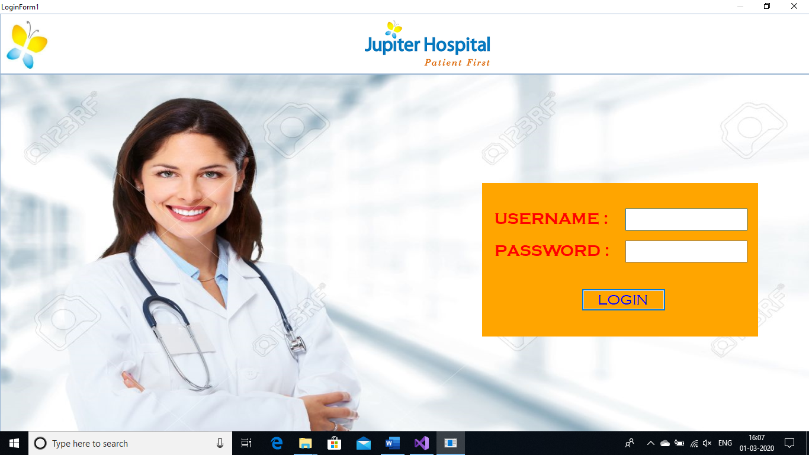**Code Output**

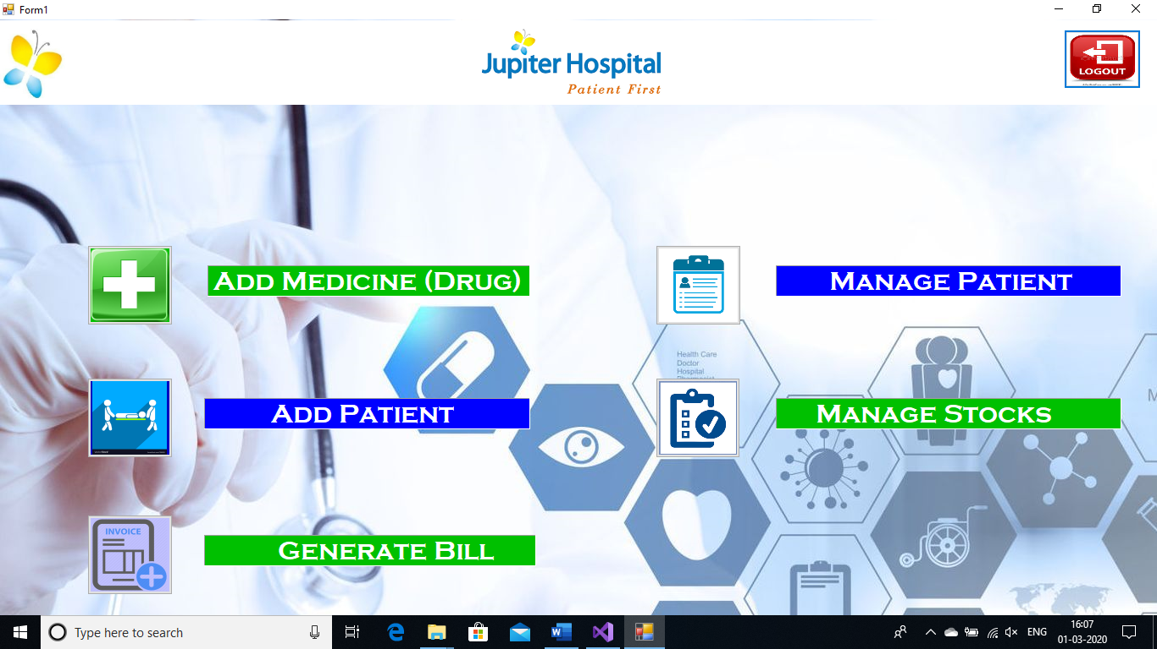

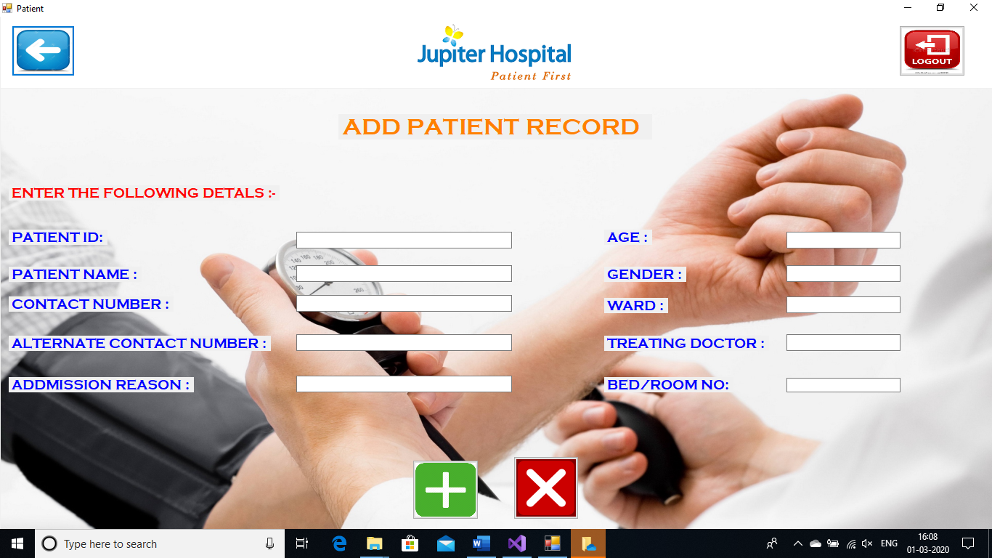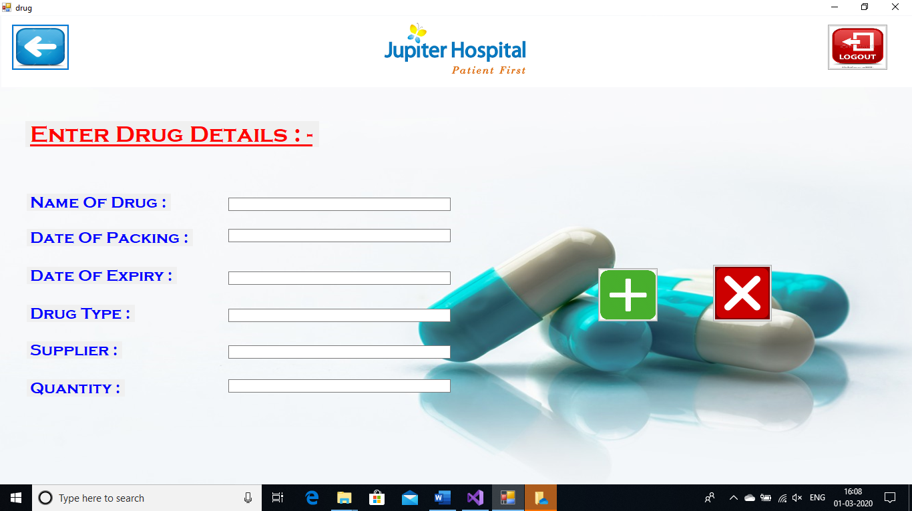

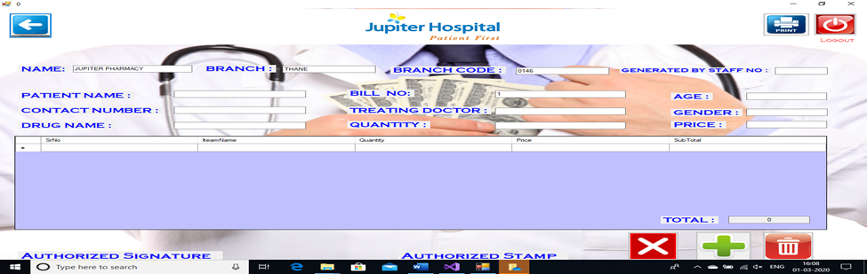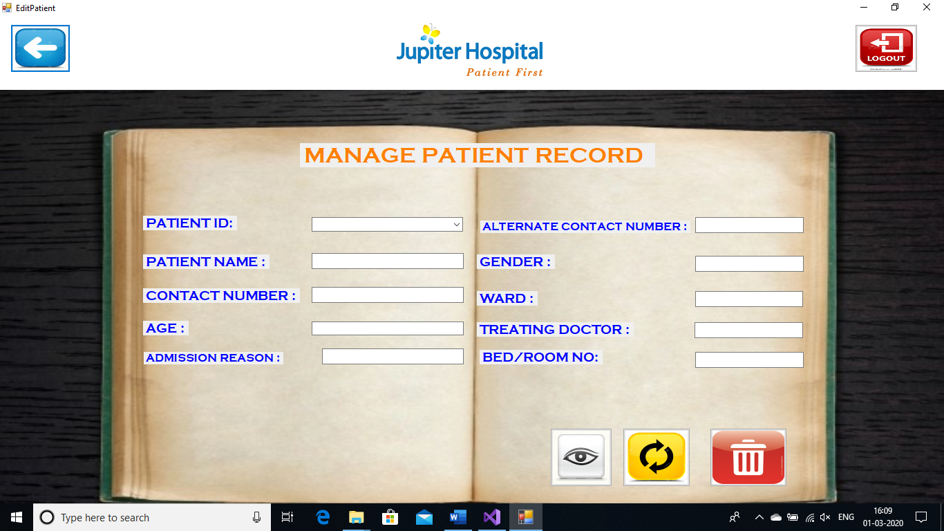

**References**

We Do Have Used A Few References During The Process Of Building Our Project. The References Used Are From Websites, Books Etc.

**The References Used Are -**

**Websites -**

1. Www.Vbtutor.Net.Com.

2. Www.Tutorialspoint.Com.

3. Www.Vb.Net-Informations.Com.

**Reference Books -**

1. Visual Basic.Net The Complete Reference
2. GUI Application Development Using Vb.Net.
3. **Skill Developed/Learning Out Of This Micro Project :**

* Since We Worked In A Group,We Developed The Skill Of ‘Teamwork’ In Us
* We Came To Know How And When To Use Some Of The Important Concept Of Visual Studios
* We Attained The Satisfied Level Of Programming